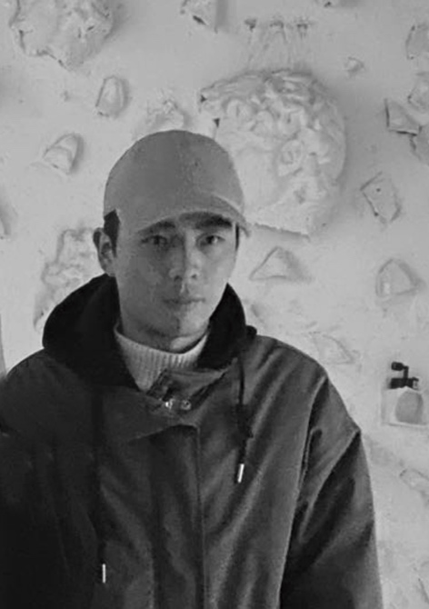
宋涛
1990年出生
2017年毕业于西安美术学院油画系，硕士研究生

展览

2017 第六届大学生（广州）艺术博览会，广州
艺术山西“年轻的世代—全国青年艺术家优秀绘画作品展”，山西
2018 约翰・莫尔绘画奖（中国），上海

Song Tao
Born in 1990
He received his BFA and MFA from Xi’an Academy of Fine Art, major in oil painting.

Exhibition
2017 Graduates Art Fair, Guangzhou, China
Art Shanxi "Young Generation - National Excellent Painting Exhibition of Young Artists", Shanxi
2018 John Moores Painting Prize(China), Shanghai, China

